**Christopher King**

**2018141521058**

**Applied Fluid Mechanics**

**Class Section 01**

**04/29/2021**

# **Problem 11.24**

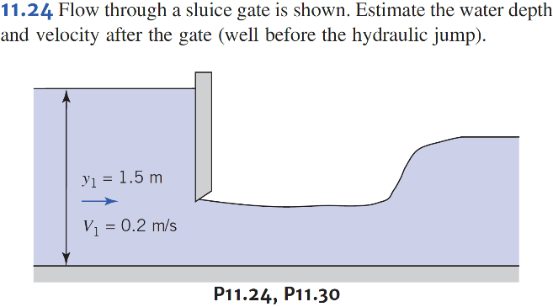

**Solution:**

Solving equation above yields that

# **Problem 11.30**



**Solution:**

Therefore,